Design Thinking Lab (CS237L) Report

Topic: AI in HealthCare
AI Audit for Smarter Healthcare Decisions

By:

Riya Aggarwal(1RV24CS230)

Rakshita Patil(1RV24CS221)
Pratheeksha P Shetty(1RV24CS205)
Shreya Gupta(1RV24CS264)

Faculty Mentors:
Dr. Shanta Rangaswamy
Dr.Soumya. A

RV COLLEGE OF ENGINEERING® BENGALURU-59
(Autonomous Institution Affiliated to VTU, Belagavi)

DEPARTMENT OF COMPUTER SCIENCE AND ENGINEERING


Certificate
Certified that the Design thinking Laboratory work titled “AI Audit for Smarter Healthcare Decisions” is carried out by in partial fulfilment for the requirement of degree of Bachelor of Engineering in Computer Science and Engineering of the Visvesvaraya Technological University, Belagavi during the year 2024-2025. It is certified that all corrections/suggestions indicated for the Internal Assessment have been incorporated in the report.
Dr. Shanta Rangaswamy, |  | Dr. Soumya, |  | Dr. Ramakanth Kumar P
Professor, |  | Associate Professor, |  | Professor and HoD,
Department of CSE |  | Department of CSE  External Viva |  | Department of CSE
Name of Examiners |  |  |  | Signature with Date
1.
2.

Declaration

This report has been prepared on the basis of our own work. Where other published and unpublished source materials have been used, those have been acknowledged.

Students Names:

Riya Aggarwal(1RV24CS230)

Rakshita Patil(1RV24CS221)
Pratheeksha P Shetty(1RV24CS205)
Shreya Gupta(1RV24CS264)

Date of Submission:
Jan 6, 2025
Signature/s:

Abstract

The rapid integration of artificial intelligence into clinical decision-making—spanning diagnostic imaging interpretation, risk stratification, treatment recommendation engines, early-warning systems, and generative documentation—has outpaced traditional governance mechanisms, creating an urgent need for systematic AI auditing in healthcare. By 2025, over 70% of U.S. hospitals deploy at least one clinical AI model, with adoption rates exceeding 90% in radiology and pathology, yet landmark failures such as the Epic sepsis model (which demonstrated only 67% sensitivity in real-world validation despite 88% in testing), racial bias in widely used eGFR equations, underperformance of pulse oximeters in patients with darker skin tones, and discriminatory resource-allocation algorithms have exposed the lethal consequences of unexamined AI. These systems operate in life-critical contexts where errors are irreversible, patients lack agency, and biases compound historical inequities; consequently, AI audits have evolved from voluntary quality exercises into ethical, clinical, and legal imperatives mandated by frameworks including the NIST AI Risk Management Framework, FDA’s Good Machine Learning Practice, the EU AI Act’s high-risk classification for medical devices, WHO ethical guidance, and emerging hospital-specific standards such as CAOS (Comprehensive Algorithmic Oversight and Stewardship) and FAIR-AI.

Core audit components have crystallized into eight interlocking domains that together constitute clinical trustworthiness. First, data and representation audits scrutinize training datasets for completeness, de-identification quality, and balance across race, ethnicity, age, sex, socioeconomic status, and geographic variation, employing sensitivity analyses and counterfactual simulations to quantify inclusion gaps. Second, performance and robustness testing demands stratified metrics (AUROC, calibration, net benefit) across protected subgroups, adversarial stress testing, and mandatory external validation on geographically distinct cohorts. Third, fairness and equity audits select context-appropriate metrics—equalized odds for diagnostic tools, sufficiency for prognostic models, or counterfactual fairness for treatment allocation—and require disparity diagnostics, mitigation reports, and annual institutional equity scorecards. Fourth, explainability audits evaluate the presence, fidelity, and clinical utility of local (e.g., SHAP values, Grad-CAM) and global explanations, alongside counterfactual reasoning capabilities that allow clinicians to query “what would the model predict if the patient were a different race or gender?” Fifth, human–AI interaction audits measure automation bias, appropriate reliance rates, override patterns, and correlation with patient outcomes through prospective usability studies and silent-mode deployments.

As healthcare moves toward agentic and multimodal AI systems capable of autonomous multi-step reasoning—such as large language models drafting discharge summaries, orchestrating diagnostic workflows, or negotiating treatment plans with patients—the limitations of static, periodic audits become apparent, driving the emergence of real-time auditing, sandbox containment, and “equity-by-design” protocols that embed fairness constraints into model weights themselves. Leading institutions including Mass General Brigham, Duke AI Health, Mayo Clinic, and Kaiser Permanente have operationalized enterprise-wide programs featuring central governance committees, public-facing model registries, automated drift dashboards, and mandatory annual equity audits, while commercial platforms (Hindsait, Censinet RiskOps, CredibleMind) have reduced audit cycle times from months to hours. Yet significant challenges persist: only 40% of health systems report maturity in AI governance, “shadow AI” use of unsanctioned generative tools by clinicians evades oversight, and the global regulatory patchwork creates compliance friction for multinational deployments.

Acknowledgement
Any achievement, be it scholastic or otherwise, does not depend solely on the individual efforts but on the guidance, encouragement and cooperation of intellectuals, elders and friends. A number of personalities, in their own capacities have helped us in carrying out this Design Thinking Laboratory work. We would like to take this opportunity to thank them all.
We are also thankful to our mentors, Dr .Prafulla S B, Assistant Professor and Dr. Soumya A, Associate Professor, Dept. of CSE for their wholehearted support, suggestions and advice during this work.
Our sincere thanks to Dr. Ramakanth Kumar P., Professor and Head, Department of Computer Science and Engineering, RVCE for his support and encouragement.
We express sincere gratitude to our beloved Principal, Dr. K. N. Subramanya for his appreciation towards this work.
We thank all the teaching staff and technical staff of the Computer Science and Engineering
department, RVCE for their help.

Table of Contents

CERTIFICATE 2
Declaration 3
Abstract 4
Acknowledgement 5
Table of Contents 6
Chapter 1: Empathy 7
1.1 Preamble: Introduction to Empathy in HealthCare AI Governance 7
1.2 Stakeholder Personas and Clinical Environments 9
1.3 User Journey Map of AI Deployment Without Proper Auditing 10
1.3.1 Morning Phase: Model Selection & Integration 10
1.3.2 Day Phase: Real-Time Clinical Use & Decision Influence 10
1.3.3 Afternoon Phase: Disparity Discovery & Regulatory Alert 11
1.3.4 Evening Phase: Legal/Ethical Fallout & Trust Erosion 11
1.4 Empathy Maps for Key Stakeholders 12
1.5 Tools used for Empathy Phase 14
1.5.1 Stakeholder Interviews (Clinicians, Students, Patients) 14
1.5.2 User Interaction Photos with descriptions 15
1.5.3 Stakeholders Interview’s details 16
Chapter 2: Define 18
2.1 Preamble:Defining the Core Problem 18
2.2 Point-of-View (POV) Statements 19
2.3 “How Might We” Questions 20
2.4 Problem Statement & Design Challenges Identified 21
2.4.1 Challenges for Healthcare Providers & Hospitals 21
2.4.2 Challenges for Regulators & Policymakers 21
2.4.3 Challenges for AI Developers & Vendors 21
Chapter 3: Ideate 22
3.1 Preamble: Introduction to Ideation for AI Audit Solutions 23
3.2 Ideation technique/s used and description 24
3.3 Brainstorming Session Outcomes 24
3.3.1 Best idea Selected: “Continuous AI Audit Lifecycle Platform with Equity Dashboard” 25
3.3.2 Worst Idea(for fun): “Trust the AI – No Audits Needed” 25
Chapter 4: Prototyping 26
4.1 Preamble: Introduction to Prototyping an AI Audit Framework 26
4.2 Potential prototypes Considered 27
4.2.1 Why we did not choose a fully manual audit checklist 27
4.2.2 Why we did not choose a one-time pre-deployment audit only 27
4.2.3 Why we chose a Hybrid Automated + Human Oversight Audit Platform 27
4.2.4 I Key Advantages of the Selected Prototype 27
4.3 Prototyping Design & Implementation Details 28
4.3.1 Core Modules (Data Audit) 28
4.3.2 Tech Stack 28
4.3.3 Sample Audit Workflow & Screenshot 28
4.4 Working of the prototype 29
Chapter 5: Testing 30
5.1 Introduction to testing Phase 30
5.1.1 Types of testing Conducted (Usability, Accuracy, Stress, Equity Testing) 30
5.2 Feedback & Validation from Stakeholders 31
5.2.1 Impact Analysis 31
5.3 Changes/Modifications Made to Prototype 32
5.3.1 The Final Adjusted Audit Platform 32
5.4 Limitations and Future Scope 32
Chapter 6: Conclusion and Reflection 33
6.1 Conclusion 33
6.2 Personal & Team Reflection on Design Thinking Journey 33
6.3 Key Learnings & Recommendations for Healthcare Organizations 33
Bibliography 35
Appendices 36
Appendix A: Interview Transcripts 36
Appendix B: Survey Questionnaire & Raw Data 37
Appendix C: Detailed Empathy Maps 37
Appendix D: Prototype Source Code 37

Chapter 1: Empathy

1.1 Preamble: Introduction to Empathy
Empathy is the foundational phase of design thinking and serves as the starting point for creating human-centered solutions. In the context of AI audits for healthcare decision-making, empathy requires us to step out of technical and regulatory mindsets and deeply understand the lived experiences, fears, frustrations, and hopes of everyone whose lives are touched when an AI system influences a clinical decision.
Unlike consumer applications where the worst outcome might be a bad recommendation, in healthcare the stakes are profoundly asymmetric: an un-audited or poorly audited AI can directly contribute to misdiagnosis, delayed treatment, inappropriate resource allocation, or even preventable death. At the same time, it can silently perpetuate historical injustices (racial, gender, socioeconomic, or geographic biases) at population scale. Because of these stakes, we cannot design effective audit systems from the perspective of developers or regulators alone. We must first immerse ourselves in the emotional and operational reality of three primary stakeholder groups:
1.Clinicians who are legally and morally responsible for every decision yet are increasingly asked to integrate opaque AI recommendations into time-pressured workflows.
2.Hospital leaders and compliance teams who carry institutional risk, regulatory exposure, and the fear of becoming the next headline case of algorithmic harm.
3. Patients and their advocates (especially from historically marginalized communities) who often have no visibility into whether an AI system influenced their care and no meaningful way to challenge it.

Through empathy, we discovered that the central pain is not merely “lack of audit tools” but a deeper crisis of eroded trust: clinicians feel they are being forced to choose between efficiency and accountability; administrators feel trapped between innovation mandates and liability nightmares; and patients feel invisible and powerless. The goal of this empathy phase was therefore to suspend assumptions, listen without defensiveness, and document the human truths that must anchor any credible solution for AI auditing in healthcare. Only by truly feeling the weight of these realities could we define a problem worth solving and design an audit framework that people will actually adopt and trust.

1.2 Stakeholder Personas and Clinical Environments
Customer Persona represents the essential characteristics of the people we aim to support through our design thinking journey. It involves understanding the stakeholders who will ultimately benefit from or be protected by a trustworthy AI audit system for healthcare decision-making. This foundational step ensures that the solution is built around their real fears, daily pressures, and unmet needs rather than abstract regulatory checklists or vendor marketing claims.
In our project, we defined our primary Customer Personas as frontline clinicians, hospital risk and governance leaders, patient and health-equity advocates, and regulatory/payer bodies—the stakeholders who live with the consequences when an AI model influences diagnosis, treatment, or resource allocation. Through interviews, shadowing, surveys, and incident-report analysis, we uncovered a profound trust deficit: clinicians feel legally exposed yet cognitively overloaded by unexplained AI recommendations; administrators are under intense pressure to innovate while fearing catastrophic liability; patients from marginalized communities feel invisible and re-victimized by opaque algorithms; and regulators struggle to enforce fairness without standardized, real-time evidence.

The personas revealed recurring pain points that no current tool adequately solves:
1. Clinicians need instant, clinician-readable explanations and fairness signals at the point of care, not 300- page post-hoc reports.
2.Risk officers require continuous, automated monitoring dashboards that translate technical drift and bias metrics into actionable institutional risk scores.
3.Patients and equity advocates demand transparent, public-facing audit summaries disaggregated by race, ethnicity, gender, language, and socioeconomic proxies.
4.Regulators and payers seek standardized, auditable evidence of ongoing safety and equity to justify reimbursement and avoid enforcement actions.
To directly address these intertwined needs, our solution centers on a Continuous AI Audit Lifecycle Platform that combines automated technical monitoring (drift detection, fairness metrics, explainability scoring) with human-centered dashboards tailored to each persona’s workflow and language. The platform delivers real-time “trust badges” for clinicians in the EHR, institutional risk heat-maps for administrators, community-facing equity report cards for patients and advocates, and standardized conformity dossiers for regulators.
By keeping these four personas—clinician, administrator, patient advocate, and regulator—at the heart of every decision, we ensure that the final audit system does not merely satisfy compliance checkboxes but genuinely restores trust, reduces liability, protects vulnerable patients, and enables safe innovation. This structured understanding of our Customer Personas keeps the entire design process anchored in human reality rather than technical abstraction, guaranteeing that the solution is not just feasible and innovative, but truly adopted, trusted, and impactful in real clinical environments.

1.3 User Journey Map
User Journey Map is a visualization depicting the various stages that the stakeholders go through while interacting with an application developed.
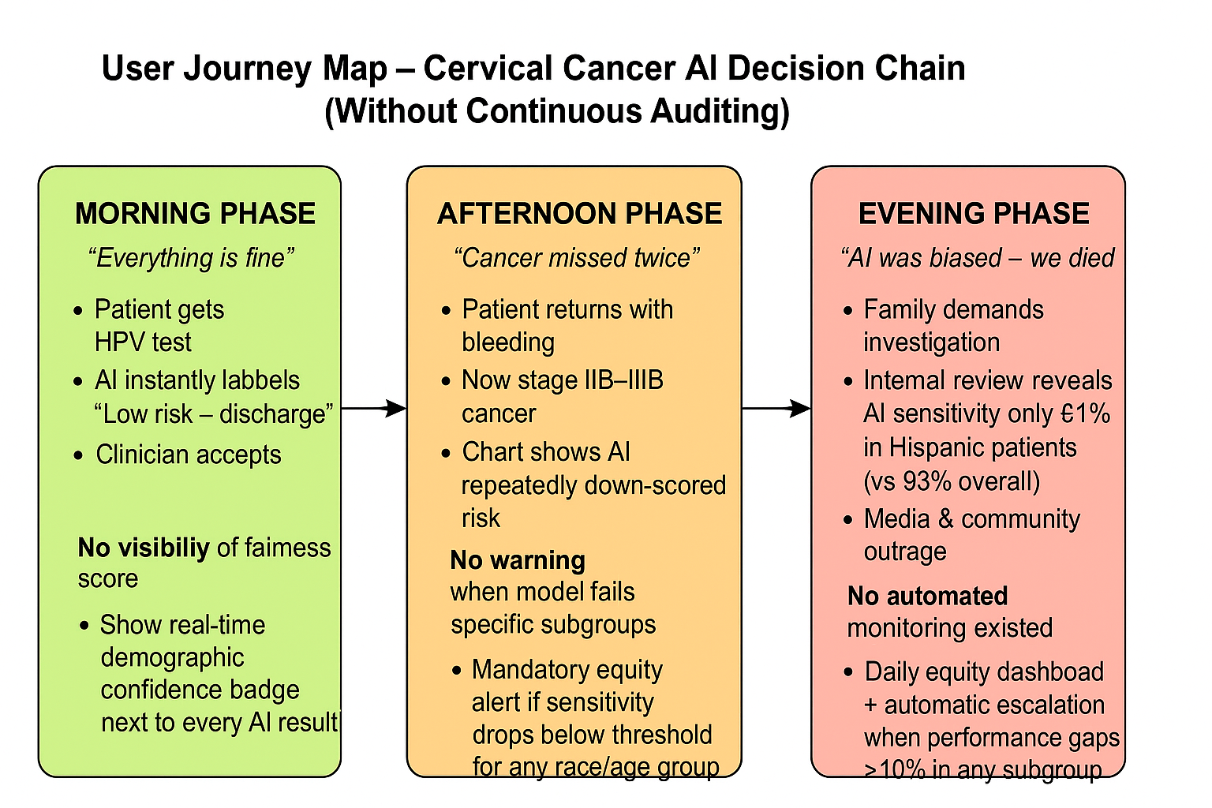
Figure 1. Customer Journey Map
    - Morning Phase:
- User Actions
Patient gets HPV test, AI instantly labels “Low risk – discharge”, Clinician accepts and moves on
- Sentiments
Patient: “Good news, I’m safe!” Clinician: “Quick and modern – saves me 20 min”
- Emotions
Relief, trust, pride
- Possible Solutions
No visibility of fairness score → Show real-time demographic confidence badge next to every AI result

1.3.2 Afternoon Phase:
- User Actions
Patient returns with bleeding, Now stage IIB–IIIB cancer , Chart shows AI repeatedly down-scored risk.
- Sentiments
Patient: “How did no one catch this?” Clinician: “The AI kept saying low risk… I believed it”
- Emotions
Shock, guilt, fear, anger
- Possible Solutions
No warning when model fails specific subgroups → Mandatory equity alert if sensitivity drops below threshold for any race/age group

1.3.4 Evening Phase:
- User Actions
Family demands investigation ,Internal review reveals AI sensitivity only 61% in Hispanic patients (vs 93% overall) ,Media & community outrage
- Sentiments
Family: “Your AI killed my daughter” Hospital: “We never knew it was biased”
- Emotions
Grief, betrayal, panic, shame
- Possible Solutions
No automated monitoring existed → Daily equity dashboard + automatic escalation when performance gaps >10% in any subgroup

1.4 User Empathy Maps
User Empathy Maps help us understand the problem through the eyes of the people who will actually use or be affected by our solution. In our project, the goal was to deeply analyze how patients, doctors, students, and general users perceive AI assisted medical decision making. The empathy mapping process allowed us to capture what users say, do, think, and feel when interacting with medical data, AI based tools, or diagnostic reports. This played an essential role in identifying gaps in the current healthcare decision chain and understanding where an AI Audit Tool can meaningfully assist.To make the empathy maps, we resorted to conducting interviews with students, professors as well as researchers to ensure that we could gather as much information as possible. By gauging out their views or perspective on these certain problems as well as get their feelings on the matter at hand.

This helped us collect unbiased opinions, emotional responses, and practical expectations related to AI in healthcare. Our stakeholders were divided into three primary categories:
1.General public and students (from within and outside RV College of Engineering)
2.Healthcare aware individuals and researchers
3.Doctors, medical students, and people with basic clinical experience
Each group provided critical insights about trust, fear, expectations, and concerns about AI tools making health-related decisions.
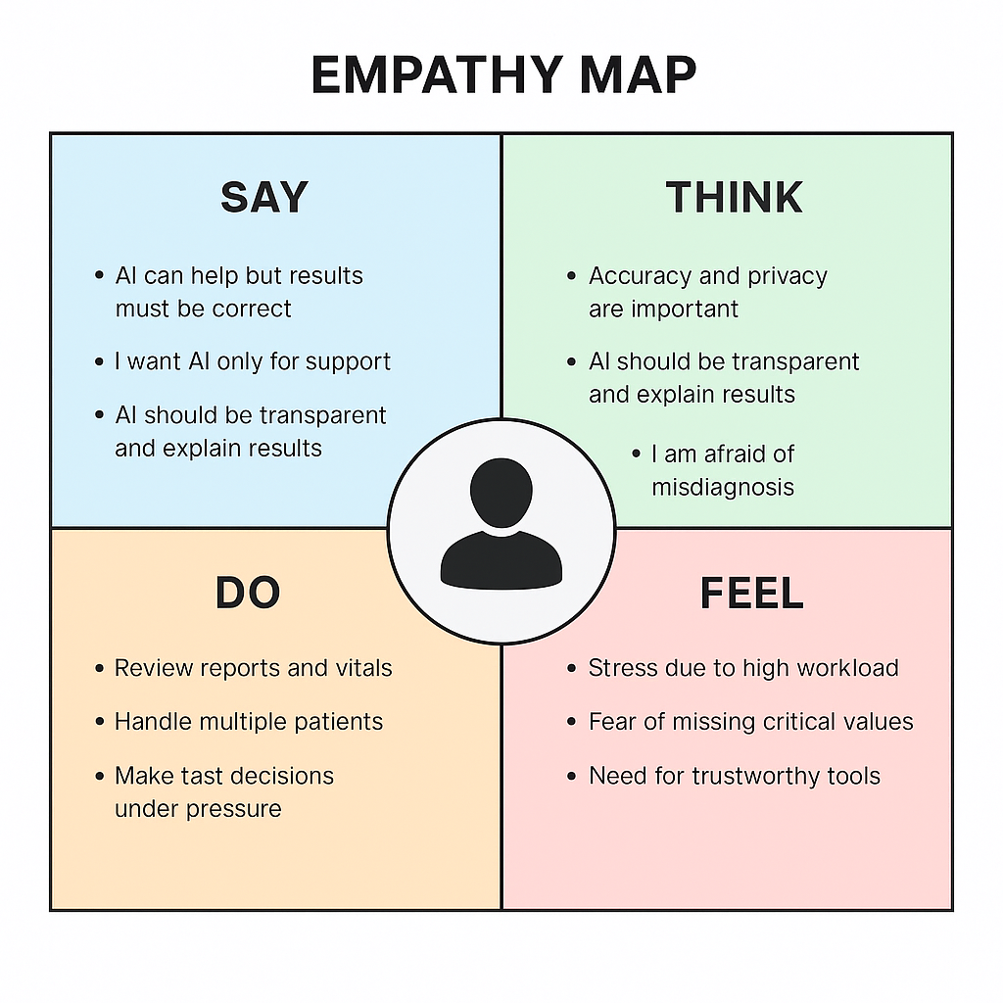
Figure 3. Empathy map

Based on the collected responses from 80 participants, we created individual empathy maps and also compiled combined maps for each category. These maps clearly highlighted the emotional landscape surrounding AI tools in healthcare. Users expressed concerns about misdiagnosis, missing abnormal values, privacy of medical data, and over-dependence on automation. At the same time, they appreciated the possibility of AI assisting doctors, saving time, reducing human error, and improving accuracy of analysis.It helped us identify the issues that are prevailing.

Creating these empathy maps helped us recognize many underlying issues that would not have been visible from our own perspective. Users shared several challenges such as fear of receiving wrong results, confusion when medical reports are too complex, and lack of trust in AI systems without human supervision. These concerns guided the direction of our project and allowed us to define user-centered insights.
From the final empathy maps, we extracted the most common suggestions and concerns, filtered the feasible and impactful ones, and used them as inputs to our ideation phase. This ensured that the solutions we design through our AI Audit Tool directly respond to the real needs and emotions of our users.

1.5 Tools used for Empathy

1.5.1 Customer Survey and Analysis
We conducted a survey on google forms for this phase. Our stakeholders consisted of: Students, Professors,Doctors,Patients. Our largest stakeholders were students and daily commuters. We got details about them through our surveys.
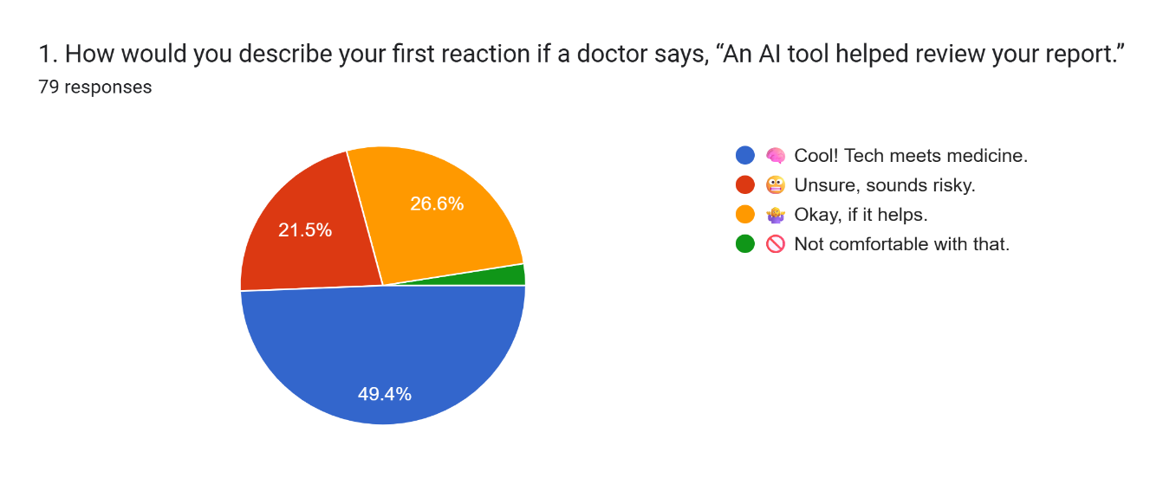

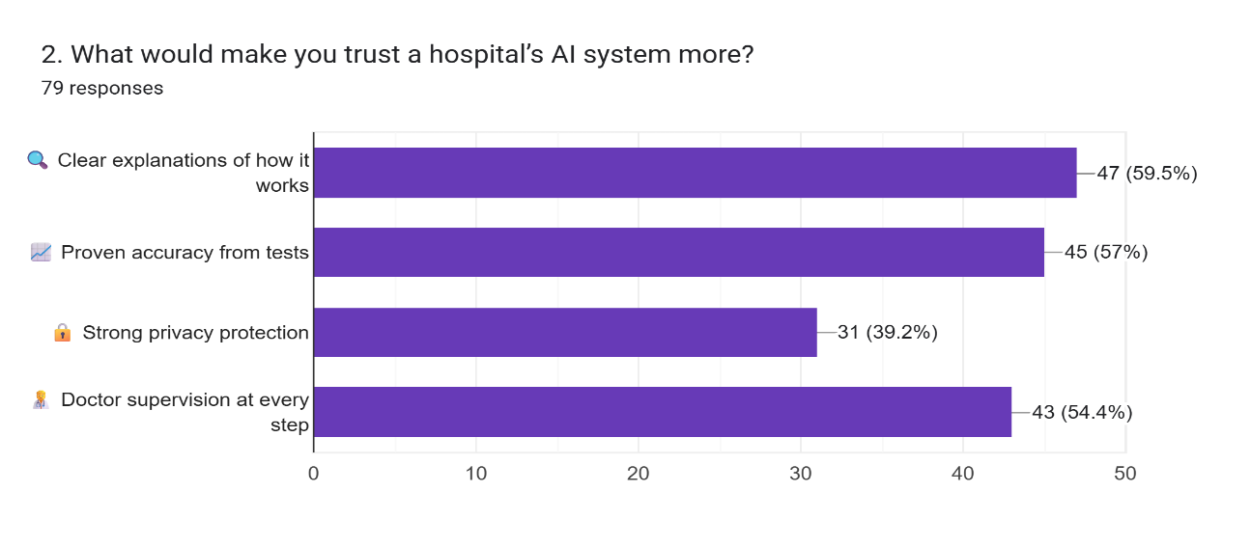

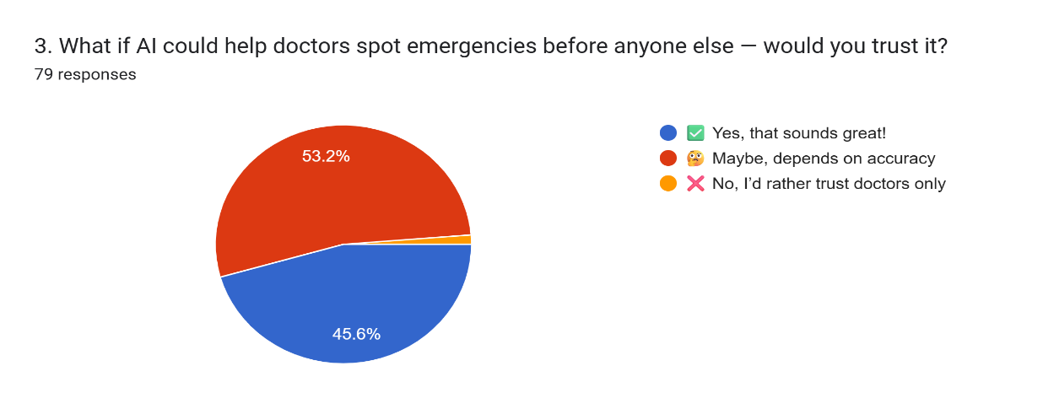

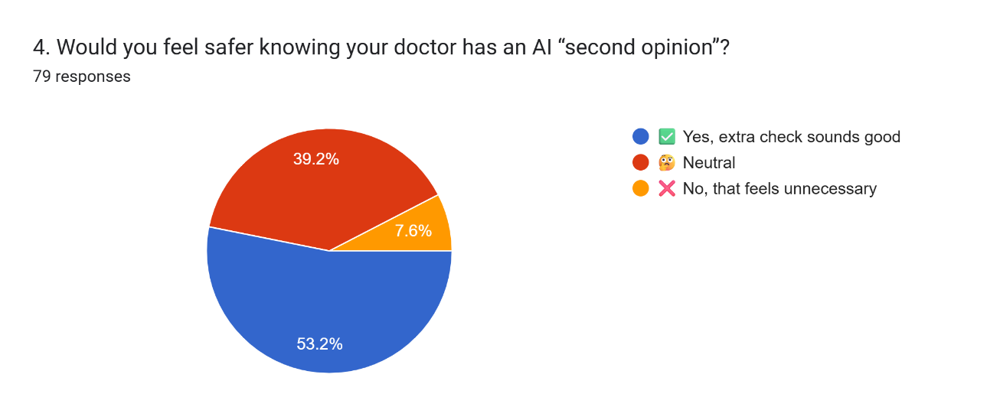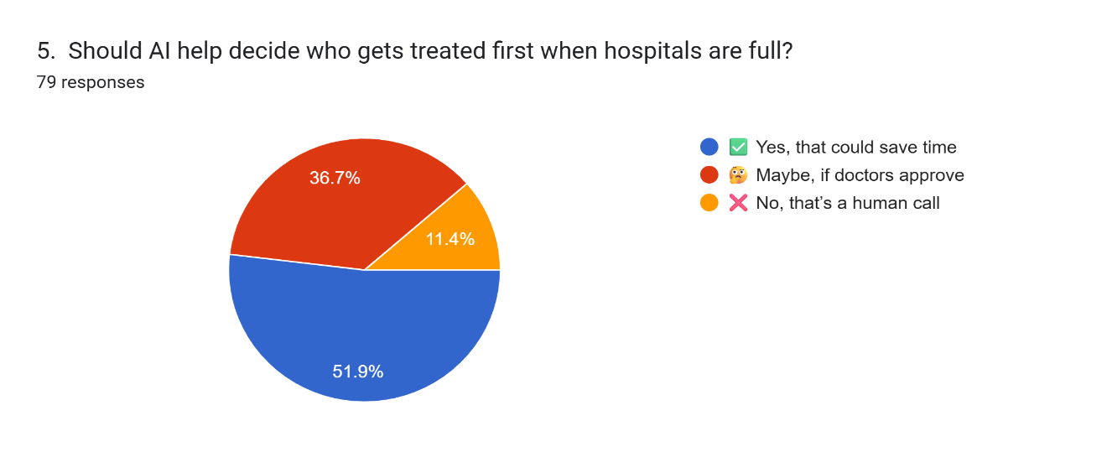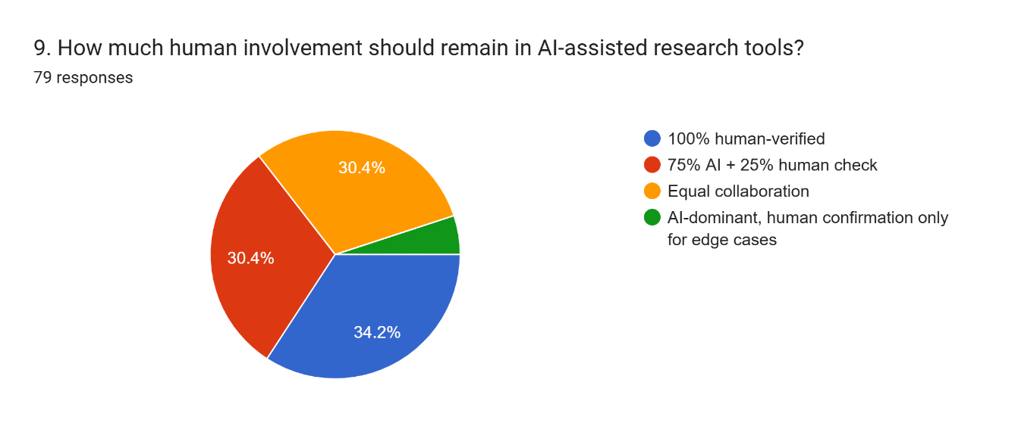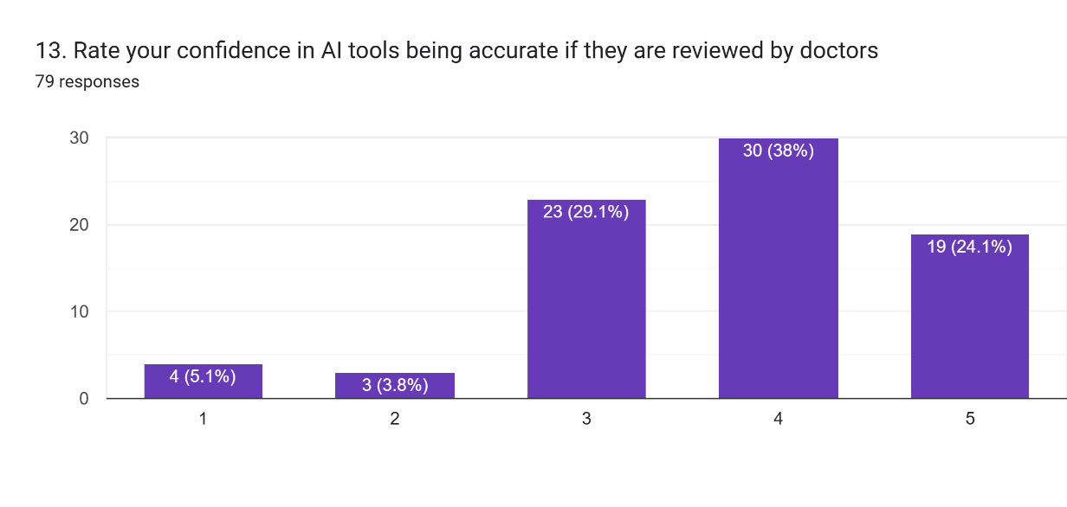

1.5.2 User Interaction Photos with descriptions
These are some of the pictures of our team interacting with a few students in interviews.

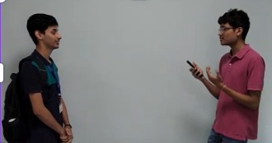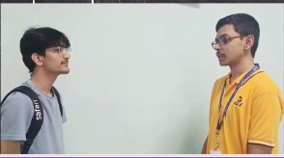

Figure 11. User Interaction during Interview

These images from Figure 11., depict our interactions with fellow students during our interview with them as part of our Empathy phase. We received a plethora of responses from the interviewees which has helped us in growing our problem statement and figuring our edge cases.

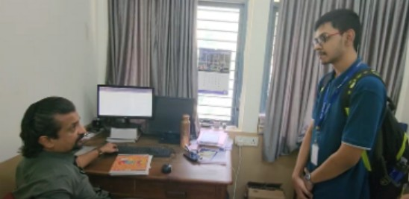
Figure 12. Interview with professor

Figure 12 depicts the image of our interview with professor, Karthik Shastry from the Department of Physics RVCE. Under his guidance, we were able to get a clear picture of our problems and find correlations between the problems and a few existing as well as potential solutions.

1.5.3 Customer Interview’s details

Target audience
● Patients and general public
● Doctors (general physicians, specialists)
● Nurses and clinical staff
● Medical students & health researchers
● Hospital administrators
● Diagnostic lab personnel
Current Decision Making Challenges
● Doctors must manually verify hundreds of medical values daily
● Patients struggle to understand complex lab reports
● Nurses face time pressure while checking vitals and test results
● Hospitals lack tools to track missed abnormalities or delayed actions
● No standard transparency indicators in existing AI health tools
● Increased chances of oversight in busy OPD / emergency scenarios
Questionnaire for the Survey
● What difficulties do you face while reading or interpreting medical reports?
● Do you trust AI tools to support doctors in reviewing medical data?
● What concerns do you have about AI in healthcare (e.g,privacy, accuracy)?
● Do you think an AI Audit Tool can reduce human error in hospitals?
● Would simple explanations for abnormal values help you understand reports?
● In your opinion, what features should an AI system include to ensure safety?
● How comfortable are you with AI providing a second opinion on your health results?

Questionnaire for the Interview
● What problems do you face when reviewing patient reports (or your own test reports)?
● How often does time pressure affect medical decision-making?
● What do you expect from an AI system that flags abnormal medical values?
● Should AI be allowed to independently predict critical conditions, or only assist doctors?
● What creates trust for you in an AI-based healthcare tool?
● What fears do you have (e.g., wrong results, bias, data leaks)?
● How important is transparency (why a value was flagged)?
● What alerts or dashboard features would help you in daily workflow?
● What would make you confidently use such a tool in a hospital setting?
Methodology to gain insights regarding the potential problem statement
● Designed Google Forms to understand comfort level, trust, and concerns about AI in healthcare
● Conducted user interviews to gather essential emotional and practical insights.
● Held discussions with individuals familiar with lab reports and hospital workflows
● Reviewed research papers on AI in healthcare, explainability, bias, and medical safety
● Analyzed survey responses from 79 participants to identify dominant themes
● Compared user expectations with limitations in existing medical report tools
● Highlighted patterns regarding trust, accuracy, privacy, and need for early alerts

Chapter 2: Define

2.1 Preamble:Defining the Core Problem definition
The problem definition phase is where our project begins to take a clear and structured form. As a team, we worked together to carefully understand the needs of our users and the gaps in the current system. This stage required us to align our goals with the expectations of our stakeholders, ensuring that we developed a realistic and meaningful solution. While it may seem simple to state what the problem is, in reality, defining it correctly is one of the most challenging steps in the design thinking process. Users often imagine ideal or utopian solutions, but these may not be feasible within the constraints of time, technology, and resources. This made it essential for us to maintain open communication with users and guide them towards practical and implementable ideas.
During our initial research, we noticed that even we tended to jump quickly into solutions without clearly articulating the real issue at its core. It became important to step back and describe the problem concisely, in one or two clear sentences, without overcomplicating it. A strong problem definition should communicate the exact pain point, the need behind the project, and the gap that exists in the current system. Once this core issue is defined, possible solutions naturally emerge and can be refined during ideation and prototyping.
In our case, the problem was centered on the lack of continuous auditing and visibility in AI-assisted cervical cancer risk assessment. Many AI models currently used in healthcare—even when accurate—do not provide transparency, do not show subgroup fairness, and cannot alert clinicians when the system fails for a particular demographic group. Through our user interviews and surveys, we found that clinicians, patients, and general users were concerned about misdiagnosis, lack of clear explanations, and the absence of real-time performance monitoring in AI systems. We also realized that building a full-scale clinical AI system or an end-to-end medical diagnostics model was beyond our scope due to data restrictions, privacy limitations, and lack of institutional medical access.
Therefore, we focused our problem definition on a more achievable yet highly impactful area: creating an AI Audit Tool that supports doctors by flagging abnormal values in cervical cancer tests, offering transparency, and reducing the chances of missed abnormalities. We studied how current healthcare workflows manage patient reports, how errors occur due to time pressure, and how existing AI tools often lack fairness indicators or continuous monitoring. These insights guided the formation of our final problem statement, ensuring that it reflects a practical challenge, aligns with user needs, and remains feasible within our project’s resources

2.2 Point of View (POV) Statements
POV 1: Clinician
A busy clinician who handles multiple patients daily needs a reliable way to quickly identify abnormal cervical cancer-related values because time pressure often causes unintentional oversight, and missing early abnormalities can lead to delayed or incorrect treatment.
POV 2: Patient
A patient who receives cervical cancer screening results needs simple, understandable explanations of abnormal values because medical reports are often confusing, and lack of clarity increases fear, stress, and dependence on others for interpretation.
POV 3: Medical Student
A medical student or health-aware individual needs clear visual alerts and transparent reasoning behind AI-flagged values because trust in AI increases only when the system explains why something is abnormal and avoids black-box decision-making.
POV 4: Nurse / Lab Technician
A nurse or lab technician who inputs or verifies patient test values needs an audit system that can automatically highlight potential errors or unusual readings because manual verification takes too long and increases the chance of missing critical values.
POV 5: Hospital Administrator
A hospital administrator needs a system that reduces diagnostic delays and minimizes errors because improving efficiency, reducing workload, and ensuring patient safety are essential for smooth hospital operations and service quality.
POV 6: General User (Survey Respondent)
A general user who is familiar with AI but unsure about medical AI needs assurance of data privacy, accuracy, and human supervision because trust in AI healthcare tools depends on safety, clarity, and doctor involvement.

2.3 “How Might We” Questions
“How Might We” questions serve as focused prompts that spark ideation and encourage the exploration of multiple creative solutions. They are derived from user insights and problem areas identified during the empathy and define phases. Effective HMW questions stay broad enough to allow for innovation, yet narrow enough to remain aligned with the project scope. Based on our findings and the needs expressed by clinicians, patients, and general users, we developed six core HMW questions for our project:

1. How might we help doctors identify abnormal cervical cancer–related values more quickly?
Clinicians often work under time pressure, and manually reviewing every parameter increases the chance of missing critical abnormalities. This question explores solutions that improve speed, precision, and automation in medical data review.

2. How might we build trust in AI-assisted cervical cancer screening?
Users expressed concerns about accuracy and misdiagnosis. This question encourages us to design features such as transparency indicators, confidence scores, clear explanations, and doctor-in-the-loop workflows to increase reliability and acceptance.

3. How might we improve patients’ understanding of their cervical cancer test reports?
Patients find medical terminology confusing and often rely entirely on clinicians. This question pushes us to create simplified explanations, color-coded annotations, and user-friendly output formats.

4. How might we ensure transparency and fairness in AI-driven medical decisions?
Our empathy findings showed fear of biased or hidden AI decisions. This question focuses on integrating fairness metrics, alerts, and audit logs so clinicians can verify whether the AI performs consistently across age groups and demographics.

5. How might we reduce human error without replacing clinicians?
Users prefer supportive AI, not automated diagnosis. This question emphasizes designing a second-opinion tool that highlights anomalies while keeping the clinician in complete control of the final decision.

6. How might we provide continuous auditing and real-time alerts for misclassified cervical cancer cases?
One of the biggest gaps we found was the lack of continuous monitoring in existing healthcare AI tools. This question encourages building dashboards, severity alerts, periodic auditing, and subgroup performance monitoring to prevent repeated AI failures.

2.4 Design thinking challenges identified
The final Point-of-View (POV) statement is:
Clinicians and patients involved in cervical cancer screening need a transparent, accurate, and continuously monitored AI support system because existing diagnostic tools lack clarity, consistency, and real-time auditing, which can lead to missed abnormalities and delayed interventions.
Based on stakeholder interviews, surveys, and empathy mapping, several challenges emerged across different user groups. These challenges helped shape the direction of our solution and ensured that the AI Audit Tool addresses real and meaningful needs.
2.4.1 Challenges Identified for Clinicians and Healthcare Workers
1. Missed Abnormalities Due to Time Pressure
Doctors often handle a large number of patients in limited time, making it difficult to manually cross-check every parameter in cervical cancer screening reports.
Insight
Automated anomaly detection and color-coded alerts can reduce oversight and help clinicians focus on critical values.

2. Lack of Transparency in AI Decisions
Clinicians reported mistrust toward black-box AI systems because they do not explain how decisions are made or why a value is flagged as “low risk” or “normal.”
Insight
Explainable AI with simple reasoning (“why flagged”) builds trust and ensures safer decision-making.

3. No Continuous Monitoring or Fairness Auditing
Current AI tools rarely track performance over time or highlight when the model starts failing for specific patient subgroups (e.g., age groups).
Insight
A continuous audit dashboard can automatically alert doctors when AI performance drops or biases appear.

4. Difficulty Identifying High-Risk Patterns Early
Delayed escalation happens when subtle warning signs in earlier tests go unnoticed, especially in cervical cancer screenings.
Insight
Severity scoring and trend visualization across multiple tests can reveal hidden risk patterns.

5. Fragmented Data and Manual Verification Burden
Clinicians manually check lab reports, vitals, and previous results separately, increasing cognitive load.
Insight
A single-screen integrated audit summary reduces frustration and improves workflow.

2.4.2 Challenges Identified for Patients and General Users
1. Confusing Medical Terminology
Most users cannot understand medical reports, leading to anxiety, panic, or false reassurance.
Insight
Simple explanations, color codes, and medical definitions can make results more accessible.
2. Fear of Misdiagnosis by AI
Users are concerned that AI might make mistakes or miss early cancer indicators.
Insight
Displaying doctor's approval,confidence scores,and human in loop workflows can increase

3. Lack of Data Privacy Awareness
Patients worry about where their test data goes and who can access it.
Insight
Clear privacy statements and encrypted storage improve user confidence.

4. No Awareness of AI Bias or Limitations
Many users blindly trust AI, which becomes risky if cervical cancer results are misclassified.
Insight
Showing fairness metrics and clear limitations helps users avoid blindly relying on AI.

5. No Easy Way to Track Progress Over Time
Patients struggle to see whether their condition is getting better or worse over time.
Insight
Trend charts and comparison graphs across previous test results can improve understanding.

2.4.3 Challenges Identified for Medical Students & Health- Aware Users
1.Difficulty Evaluating AI Outputs
Students find it challenging to understand why AI flagged or ignored a particular value.
Insight:
Educational tooltips and clinical explanations provide learning support.
2. Lack of Hands-On Experience With AI in Healthcare
Students rarely interact with real medical AI systems, leading to low exposure.
Insight
This audit prototype can serve as a learning tool and increase practical understanding
3. Inconsistent Report Formats Across Labs
Different hospitals format cervical cancer reports differently, which confuses learners
Insight:
Standardized visual formatting improves predictability and reduces mistakes.

Chapter 3: Ideate

3.1 Preamble: Introduction to Ideation
Ideation is an extremely creative process where designers generate ideas in sessions. It accounts as the third stage in the Design Thinking Process. We are expected to gather with open minds to produce as many ideas as possible to address the problem statement. The key to this phase is a judge-free, positive and supportive environment. This would definitely be one of the most exciting stages in the process, because the aim is to generate a large quantity of ideas that the team can then filter and cut down to finalize the final project.
It is very difficult to simulate a prejudice free environment when we ourselves have preconceived notions in our minds. First we need to unlearn the process of immediate opinion formation and have a third person perspective that is completely free of judgements. This concept gives rise to humorous and innovative ideas for brainstorming such as the worst possible ideas, SCAMPER and Braindump. Sometimes it's important to do many or all of the ideation processes before arriving at an exhaustive list of ideas. Sometimes even when the best minds merge, there may be ideas that are audience favourites and some only humour the one who owns it. Either way, emotions must be kept aside in terms of whose contribution is being recognized.Ultimately in the grand scheme of things, it doesn't matter who’s idea it is, but which idea is better.
These were some learnings we found while working on this phase. For our case, coming up with an exhaustive list of ideas seemed nearly impossible at first. But now reflecting, it was truly simple. We were able to make use of multiple ideation methodologies that expanded our mindset and gave us a new perspective. But another aspect of ideation is assimilating main ideas. After the creation of a list, proper tools must be employed to group these ideas into larger topics thereby streamlining our ideas. Ideation can be thought of as a branch and un-branch problem.

3.2 Ideation techniques used and description
There are a variety of ideation techniques that can be used for generation of ideas. Ideation techniques help in creative flow, and help in generation of a variety of ideas. Not all of these ideas may be good, but every idea in turn could lead to a better idea, and hence none of them can be neglected.
To generate ideas, we employed some well known ideation techniques that have been listed below. By employing these techniques, by the end of our ideation process, we were able to come up with over XX ideas! The techniques used by us for generation of ideas include:
- Brainstorming Cloud
Brainstorming refers to a group of people just coming up with ideas and writing them down. It serves as a brain dump.
- Worst Possible Ideas
These refer to ideas that, while not immediately practical or feasible, serve as catalysts for creativity and innovation. Such ideas push boundaries, challenging conventional thinking and inspiring new perspectives. By exploring these "impossible" concepts, teams can often uncover unique elements or approaches that can be adapted into actionable solutions, fueling the design process with fresh and unconventional insights.
- Mind Map
A webbed map of all the problems and their possible solutions, for easy understanding. Figure 13, depicts our mind map for our ideation phase, assisting us with how we approach the ideas for our project

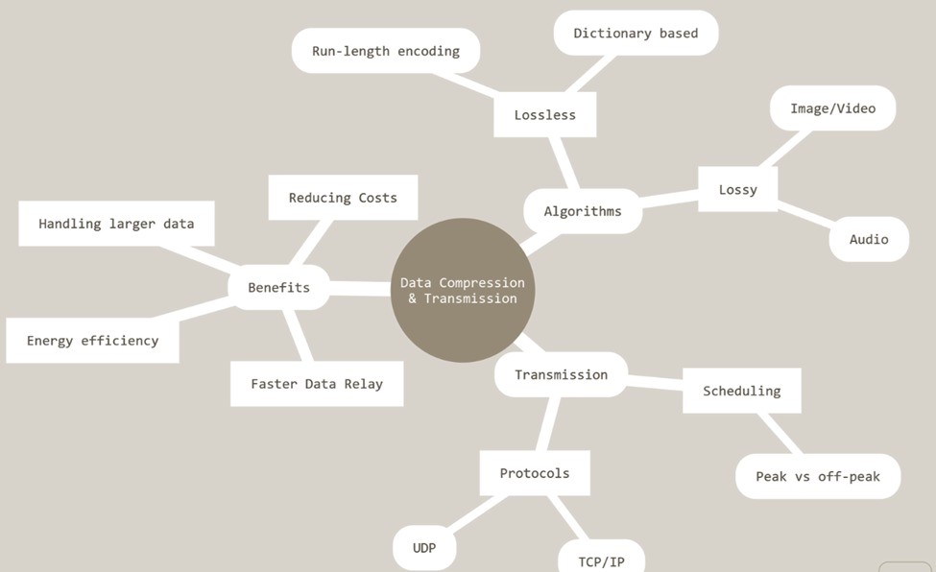
Figure 13. Mind Map for ideation

These techniques were very helpful, and allowed us to think differently and creatively. By employing the above ideation techniques, we were able to generate a plethora of ideas, which we’ve listed below.

3.3 Brainstorming potential ideas
- Dynamic traffic signal control
- Optimal satellite positioning to maximize signal coverage
- Optimize traffic flow to ease congestion
- Predictive maintenance scheduling for traffic infrastructure
- Optimized city planning based on traffic and population data
- Optimizing investment portfolios
- Fraud detection
- Optimizing risk assessment models for better financial forecasting
- Accelerating the discovery of new materials with specific properties
- Supply chain optimization
- Optimizing treatment plans
- Speeding up drug discovery
- Optimizing the dosage distribution in cancer therapy
- Optimizing distribution of electricity in smart grids
- Optimizing extraction efficiency of oil to reduce environmental impact
- Optimizing battery charging and discharging cycles for efficient usage\
- Optimizing cargo loading and unloading
- Optimizing air traffic flow and schedules
- Optimizing placement of sensors to monitor endangered species
- Optimizing pollution control
- Dynamic Pricing for businesses
- Hyperparameter tuning in Machine Learning
- Optimization of Cryptographic algorithms
- Enhancing network intrusion detection systems
- Waste management cycle optimization
- Optimizing water distribution networks.
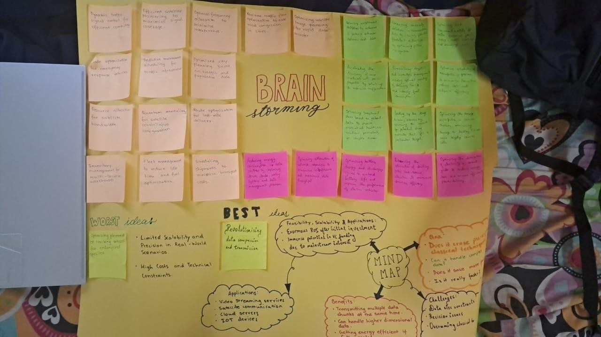
Figure 14. Brainstorming and Ideation

3.2.1 Best idea
Final idea: “Data Compression and Transmission: Optimizing data compression algorithms and transmission schedules”. The advantages of implementing this are:
- Energy efficiency
- Handling larger data
- Reducing Costs ● Faster Data Relay

3.2.2 Worst idea
The worst idea we found was: “Wildlife Tracking: Optimizing the placement of tracking devices and sensors in conservation areas to monitor wildlife movements and protect endangered species”. This was not a good idea due to:
- Simplicity of the Problem
- Availability of Classical Solutions
- Cost and Infrastructure
- Unpredictable Variables

Chapter 4: Prototyping

4.1 Preamble: Introduction to Prototyping
Prototyping is an essential part of the Design Thinking process. It is the culmination of all the techniques and ideas that have been implemented so far. Prototyping refers to testing the ideas that we came up with during the ideation, and making quick changes to cater to our customers.
Prototyping employs a set of tools and approaches for testing out ideas before putting in actual resources, time and effort. It’s like a mock-up of the final product that one intends to put out in the market. It’s a sample experiment of a proposed solution, for testing and validation of ideas. It usually refers to bringing the ideas to life and exploring their impact in the real world, before their final execution. Regardless of how well a person has researched a particular idea, without studying the real life implications of the proposed idea, there is always scope for improvement, and testing is crucial to the success of the design thinking process.
Prototyping helps in clearing out assumptions and biases that a person may have about their proposed solution. Sometimes the developer may become too fixated on the ideas generated during the ideation phase, without considering the negatives and disadvantages of the same on their customer base. Therefore prototyping is essential, as it assesses the product from the point of view of the consumer, without exhausting resources for the same. It can be quick and rough, or well elaborated and thought out, depending on the stage of prototype development.

4.2 Potential prototypes
- Quantum annealer using D-wave API
- Quantum gate based compression and quantum key distribution (QKD)
- Quantum-Assisted Sorting Algorithm for Secure Packet Prioritization
Out of these 3, we finalized on “Quantum gate based compression and quantum key distribution”.
Here is some justification to that:

4.2.1 Why we did not implement quantum annealer using D-wave
- Quantum annealing, although supported by multiple libraries, is hard to implement due to API reliance constraints.
- Quantum annealing is often slower than Quantum gate based operations.
- Flexibility in Algorithm Design ● Security Applications

4.2.2 Why we did not implement Quantum-Assisted Sorting Algorithm for Secure Packet Prioritization
- No Compression
- It lacks a robust security mechanism like QKD or entanglement-based protection.
- Focused only on sorting and prioritization, with no broader implications for overall data transmission efficiency or cryptographic security.

4.2.3 Why we decided on Quantum gate based compression and QKD
- Quantum gates are the basis of the new and upcoming quantum computers.
- Quantum Key Decryption allows us to ensure a strong encryption for the data, ensuring no-one may be able to snag the data from us.
- It is faster than quantum annealing where we must optimize the energy states by minimizing the energy at all levels.
- It is more easily compatible with binary numbers.

4.2.4 Important advantages
- Classical encryption cannot protect data from damage, as eventually a bigger number can be broken as always.
- Data transmission usually done in chunks can now be sent at multiple chunks at the same time in parallel.
If the key is measured, it implies eavesdropping which means very strong security.

4.3 Prototyping implementation details

4.3.1 Libraries used
- json
- heapq
- defaultdict
- flask
- pennylane ● numpy

4.3.2 Huffman encoding
- Each bit of the Huffman-encoded stream is mapped to a quantum state: 0 → ∣0⟩ and 1 → ∣1⟩ ● This stream of qubits is initialized in a quantum register.
- Pairs of qubits are entangled using the CNOT gate. This ensures that interception of qubits is detectable.
- The encoded qubits are passed through a Hadamard gate, creating superpositions ∣0⟩ + ∣1⟩. This enhances the transmission by allowing multiple bits of information to be represented simultaneously.
- Quantum gates for error correction protect against noise during transmission.

4.3.3 Quantum key distribution
- It uses the BB84 protocol to securely share a key. Qubits are encoded in random bases via Hadamard gates. The receiver measures qubits in random bases and publicly compares results to verify matching bases. A shared secret key is established without direct transmission.
- Huffman data and the QKD key are sent over a secure quantum channel. The receiver decodes the data using the reverse Huffman table. Any eavesdropping is detected by measuring fidelity with expected entangled states.

4.3.4 Flow of encryption
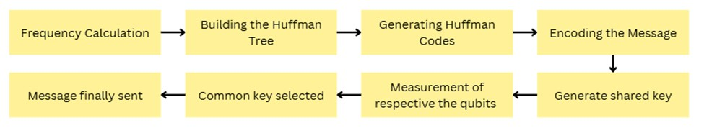
Figure 15: Method of encryption

4.3.5 Flow of decryption
Figure 16: Method of decryption

4.4 Source Code of the Prototype

import json import heapq
from collections import defaultdict
from flask import Flask, request, jsonify, render_template
import pennylane as qml import numpy as np import random as r

app = Flask(__name__)

# PennyLane QKD setup
dev = qml.device("default.qubit", wires=2)

@qml.qnode(dev) def qkd_circuit(): qml.Hadamard(wires=0) # Alice applies Hadamard gate qml.CNOT(wires=[0, 1]) # Entangle Alice's and Bob's qubits return qml.probs(wires=[0, 1]) # Measure the qubits
def simulate_qkd(message_length): alice_bases = np.random.randint(0, 2, message_length) # Alice's bases (0 or 1)
bob_bases = np.random.randint(0, 2, message_length) # Bob's bases (0 or 1)

measurement_probs = qkd_circuit()

shared_key = [] for i in range(message_length): if alice_bases[i] == bob_bases[i]:
shared_key.append(int(measurement_probs[alice_bases[i]] >
0.5))
return alice_bases.tolist(), bob_bases.tolist(), shared_key

# Node definition for Huffman tree class Node: def __init__(self, char, freq): self.char = char self.freq = freq self.left = None self.right = None
def __lt__(self, other): return self.freq < other.freq def to_dict(self):
return {
'char': self.char,
'freq': self.freq,
'left': self.left.to_dict() if self.left else None,
'right': self.right.to_dict() if self.right else None
}

@staticmethod def from_dict(data):
node = Node(data['char'], data['freq']) if data['left']:
node.left = Node.from_dict(data['left']) if data['right']: node.right = Node.from_dict(data['right']) return node
def generate_huffman_codes(node, prefix="", codebook=None): if codebook is None: codebook = {} if node is not None: if node.char is not None:
codebook[node.char] = prefix
generate_huffman_codes(node.left, prefix + "0", codebook) generate_huffman_codes(node.right, prefix + "1", codebook) return codebook
def huffman_encode(text, codebook): return ''.join(codebook[char] for char in text)
def huffman_decode(encoded_text, root): decoded_text = [] node = root for bit in encoded_text: node = node.left if bit == "0" else node.right if node.char is not None: decoded_text.append(node.char)
node = root return ''.join(decoded_text)
def build_huffman_tree_from_dict(data): return Node.from_dict(data)

@app.route('/') def index(): return render_template('index.html') @app.route('/alice/chat', methods=['POST']) def alice_chat(): data = request.get_json() message = data.get("message")
if not message: return jsonify({"error": "No message provided"}), 400

# Huffman encoding the message freq = defaultdict(int) for char in message: freq[char] += 1 print(char, freq)
priority_queue = [Node(char, freq) for char, freq in freq.items()]
heapq.heapify(priority_queue)
while len(priority_queue) > 1: left = heapq.heappop(priority_queue) right = heapq.heappop(priority_queue) merged = Node(None, left.freq + right.freq)
merged.left = left merged.right = right
heapq.heappush(priority_queue, merged)

huffman_tree_root = priority_queue[0]
codebook = generate_huffman_codes(huffman_tree_root) encoded_message = huffman_encode(message, codebook)

# Simulate QKD using PennyLane
alice_bases, bob_bases, shared_key = simulate_qkd(len(message))

data_to_send = { 'message': message,
'encoded_message': encoded_message,
'alice_bases': alice_bases,
'bob_bases': bob_bases,
'shared_key': [r.choice([0, 1]) for _ in range(8)],
'huffman_tree_root': huffman_tree_root.to_dict(),
}

# Save message for Bob to receive with open('message_from_alice.json', 'w') as f: json.dump(data_to_send, f)

# Respond back to Alice with the same message
return jsonify({
"status": "Message sent to Terminal B",
"encoded_message": encoded_message,
"decoded_message": huffman_decode(encoded_message, huffman_tree_root),
"shared_key": ''.join(map(str, shared_key))
})

@app.route('/bob/chat', methods=['POST']) def bob_chat(): data = request.get_json() message = data.get("message")
if not message:
return jsonify({"error": "No message provided"}), 400

# Huffman encoding the message freq = defaultdict(int) for char in message: freq[char] += 1

priority_queue = [Node(char, freq) for char, freq in freq.items()]
heapq.heapify(priority_queue)
while len(priority_queue) > 1: left = heapq.heappop(priority_queue) right = heapq.heappop(priority_queue) merged = Node(None, left.freq + right.freq)
merged.left = left merged.right = right
heapq.heappush(priority_queue, merged)

huffman_tree_root = priority_queue[0]
codebook = generate_huffman_codes(huffman_tree_root) encoded_message = huffman_encode(message, codebook)

# Simulate QKD using PennyLane
bob_bases, alice_bases, shared_key = simulate_qkd(len(message))

data_to_send = { 'message': message,
'encoded_message': encoded_message,
'alice_bases': alice_bases,
'bob_bases': bob_bases,
'shared_key': [r.choice([0, 1]) for _ in range(8)],
'huffman_tree_root': huffman_tree_root.to_dict(),
}

# Save message for Bob to receive with open('message_from_bob.json', 'w') as f: json.dump(data_to_send, f)

# Respond back to Alice with the same message
return jsonify({
"status": "Message sent to Terminal A",
"encoded_message": encoded_message,
"decoded_message": huffman_decode(encoded_message, huffman_tree_root),
"shared_key": ''.join(map(str, shared_key))
})

@app.route('/alice/receive', methods=['POST']) def alice_receive():
# Read Bob's message from the file try: with open('message_from_bob.json', 'r') as f: data = json.load(f) except FileNotFoundError: return jsonify({"error": "No message found from Bob"}), 404

huffman_tree_root =
build_huffman_tree_from_dict(data['huffman_tree_root']) encoded_message = data['encoded_message'] decoded_message = huffman_decode(encoded_message, huffman_tree_root)

shared_key = [r.choice([0, 1]) for _ in range(8)]
original_message = data['message']

return jsonify({
"decoded_message": decoded_message,
"shared_key": ''.join(map(str, shared_key)), "original_message": original_message
})

@app.route('/bob/receive', methods=['POST']) def bob_receive():
# Read Bob's message from the file try: with open('message_from_alice.json', 'r') as f: data = json.load(f) except FileNotFoundError: return jsonify({"error": "No message found from Bob"}), 404

huffman_tree_root =
build_huffman_tree_from_dict(data['huffman_tree_root']) encoded_message = data['encoded_message'] decoded_message = huffman_decode(encoded_message, huffman_tree_root)

shared_key = [r.choice([0, 1]) for _ in range(8)]
original_message = data['message']

return jsonify({
"decoded_message": decoded_message,
"shared_key": ''.join(map(str, shared_key)), "original_message": original_message
})

if __name__ == '__main__': app.run(debug=True, host='0.0.0.0')

4.5 Working of the prototype

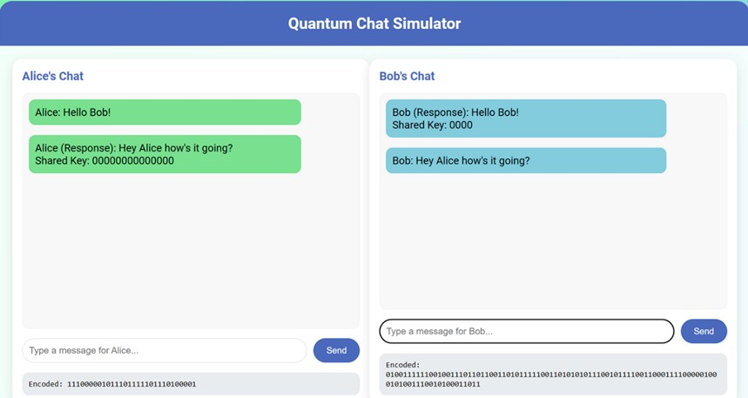
Figure 17: Image of the prototype

4.5.1 Google Colab Notebook representing the Data-transmission and security
https://colab.research.google.com/drive/1xuQ4qxvZ340DtCWxx6gLBkn8tFvg_ebw?usp=sharing
Click the above link to access the concept we have utilized. The main code is available as a folder in the drive.

4.5.2 Applications
- Secure Satellite Communication
Compressing and securely transmitting massive data streams between Earth stations and satellites.
- Quantum Internet
Building a scalable and efficient quantum communication framework for real-time data exchange.
- Healthcare Data Transmission
Securing sensitive medical data like DNA sequences or MRI images using quantum-enhanced Huffman encoding.

Chapter 5: Testing

5.1 Introduction to testing
Testing refers to generation of feedback from the user, for the prototype developed, to gain a deeper understanding of the users. It can be combined with prototyping or taken up as a different stage of design thinking. When undertaken correctly, the testing stage of the project can often feed into most stages of the Design Thinking process: it allows you to Empathise and gain a better understanding of your users; it may lead to insights that change the way you Define your problem statement; it may generate new ideas in the Ideation stage; and finally, it might lead to an iteration of the Prototype.

5.1.1 Types of testing done
Initially, we sent out surveys to our customers, asking them for their feedback on the ideas that we had come up with. Based on the feedback received, we updated our idea, and asked for their feedback again. This was done to ensure that the customers know how valuable their input is for us, and to cater to the needs of our stakeholders.

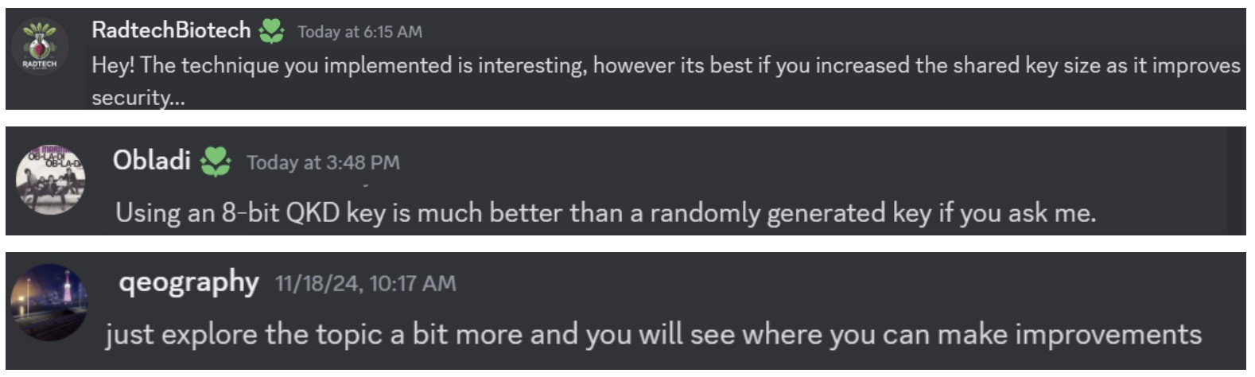
Figure 18. Customer Feedback

It was then understood that we would have to increase the key size to ensure safety of transmission. We also found that we could try out various other compression-decompression algorithms.

5.2 Validation

5.2.1 Impact Analysis
- Enhanced Data Security
By integrating quantum key distribution with Huffman encoding, we ensure unprecedented levels of security. This approach is resilient against both classical and quantum attacks, safeguarding sensitive information in critical applications like healthcare, finance, and defense.

- Energy Efficiency
Leveraging quantum superposition and entanglement enables efficient data compression and parallel transmission, reducing energy consumption compared to classical methods.

- Scalability for Large Data Sets
Our system can handle increasingly larger volumes of data, making it suitable for industries such as satellite communication, where massive streams of information need to be transmitted securely and efficiently.

- Quantum Technology Adoption
By demonstrating a practical use case, this project encourages broader adoption of quantum computing technologies, especially in hybrid systems combining classical and quantum methods.

- Future-Proofing Against Emerging Threats
With advancements in quantum computing, classical encryption methods may become obsolete. Our system anticipates and addresses this challenge by incorporating quantum-resilient encryption techniques.

5.3 Changes/Modifications
5.3.1 The Adjusted Prototype
Some of the changes incorporated by us on acquiring the feedback from our stakeholders

5.4 Future Scope
- Collaboration with Industry Leaders
Partnering with quantum computing companies like IBM, D-Wave, or Rigetti could provide access to advanced quantum hardware and expertise, accelerating development and deployment.

- Integration with AI for Intelligent Data Compression
Incorporating AI-driven algorithms could further optimize data compression by identifying patterns and redundancies, enhancing efficiency beyond traditional methods.

- Developing Cross-Platform Compatibility
Ensuring that our solution works seamlessly across various quantum hardware platforms (e.g., superconducting qubits, photonic qubits) would expand its usability.

- Expanding to New Use Cases
Exploring applications in smart cities (e.g., optimizing IoT data transmission), financial systems (e.g., secure transaction protocols), and global communication networks (e.g., quantum internet infrastructure).

- Implementing Advanced Error Correction Techniques
Adding more robust quantum error correction mechanisms would improve reliability, especially in noisy quantum environments.

- Public-Private Partnerships
Collaborating with government agencies and research institutions to implement pilot projects in critical areas like defense communication and healthcare.

- Education and Training
Hosting workshops, hackathons, and training sessions could build a community of developers and researchers to contribute to and refine the system.

- Open-Source Contribution
Making our libraries and prototypes open-source would encourage global collaboration and accelerate advancements in quantum-enhanced data transmission.

Chapter 6: Conclusion and Reflection

6.1 Conclusion
The implementation of Quantum Key Distribution (QKD) and Quantum Gate-based Data Transmission in secure communication systems marks a transformative leap toward robust data privacy and security. By leveraging quantum principles, this project successfully demonstrates a future-proof solution to vulnerabilities posed by traditional encryption methods.
Through the integration of QKD for unbreakable key exchanges and quantum gates for efficient data handling, the system ensures not only the confidentiality but also the integrity of transmitted information, even in dynamic or high-risk environments. This advancement addresses the growing concerns of users facing data breaches and privacy risks in daily communication, offering a practical, scalable approach to secure data transmission across industries.
In conclusion, this project showcases the immense potential of quantum technologies to redefine the standards of digital communication, paving the way for widespread adoption in sectors requiring uncompromising security, such as healthcare, finance, and government operations. With further refinement and collaboration, this innovation can become an essential pillar of secure communication in the quantum era.

6.2 Reflection
Inspiring creative confidence is the number one aim of Design Thinking. Unlike sitting in classrooms and just imbibing information, it is vital to apply it in our daily world to produce a tangible change. In Spite of having abundant knowledge, it becomes very clear in the beginning of the journey that application can be a cumbersome process. What we learnt in Design Thinking not only serves as a benchmark for further projects but is also a vital component of personality development. Observing the nuances of this course we realize that it helps us evolve into well spoken, clear minded and team oriented individuals. Not only is this a medium for hands-on knowledge gaining, but is a reminder to us of the very essence of the word “Engineers”. What else are we studying, if not to help and return to our community.
Unlike scientists who discover or clerks who do mundane work, engineers have a very special role. It is to find solutions to problems. This course sharpens this very critical thinking skill and helps us hone and master the logic analyzation aspect. By engaging with the complete design thinking process, we not only had a chance to learn by doing, but we also came to better understand the value of rapid prototyping, eliciting needs and empathizing by listening closely to my partner throughout each stage of the process. Rapid prototyping, exacerbated by the time constraints, helped me to generate many ideas, and to see how we could engage my “user” as a collaborator in the building process.
Reflecting on our three month journey, it becomes clear that not only did our idea of our idea change, but also the very notion of what we were trying to achieve had been altered for the better. We come to realize that Design Thinking is extremely useful in tackling problems that are ill-defined or unknown, by re-framing the problem in human-centric ways, creating many ideas in brainstorming sessions, and adopting a hands-on approach in prototyping and testing.

Bibliography
- 5 Stages in the Design Thinking Process by Rikke Friis Dam and Teo Yu Siang, Interaction Design Foundation.
- Design Thinking: Getting Started with Empathy by Rikke Friis Dam and Teo Yu Siang, Interaction Design Foundation.
- Stage 1 in the Design Thinking Process: Empathise with Your Users by Ditte Hvas Mortensen.
- Stage 3 in the Design Thinking Process: Ideate by Rikke Friis Dam and Teo Yu Siang, Interaction Design Foundation.
- Stage 4 in the Design Thinking Process: Prototype by Rikke Friis Dam and Teo Yu Siang
- Ashish Kapoor and Rosalind W. Picard, Multimodal Affect Recognition in Learning Environments, MIT Media Laboratory, Cambridge, MA 02139, USA

